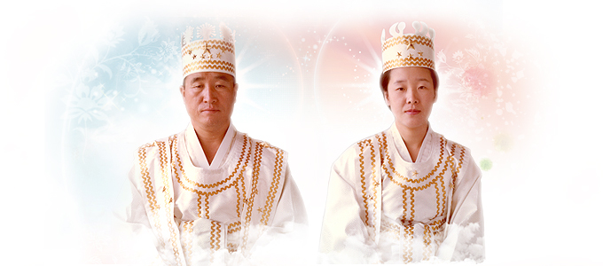

BLESS-ED
Blessing Life Guidance – True Parents’ Words

The Vision for BLESS-ED: To help Blessed Central Families understand and fulfill the transformative potential of the Blessing: Kingdom Cornerstones Recreated through God’s True Love who have Actualized the Three Blessings. Help make BLESS-ED a reality

Contact Alice Fleisher for details at
bcfcurriculum2017@gmail.com

The Blessed Central Family Life Guidance Curriculum Project is a grassroots group initiative. Phase I of this project was started in 2017 by Alice Fleisher and a small team of like-minded Unification brothers and sisters. Our target for completing phase I (collecting quotes from designated speeches phase) is the end of 2022.

