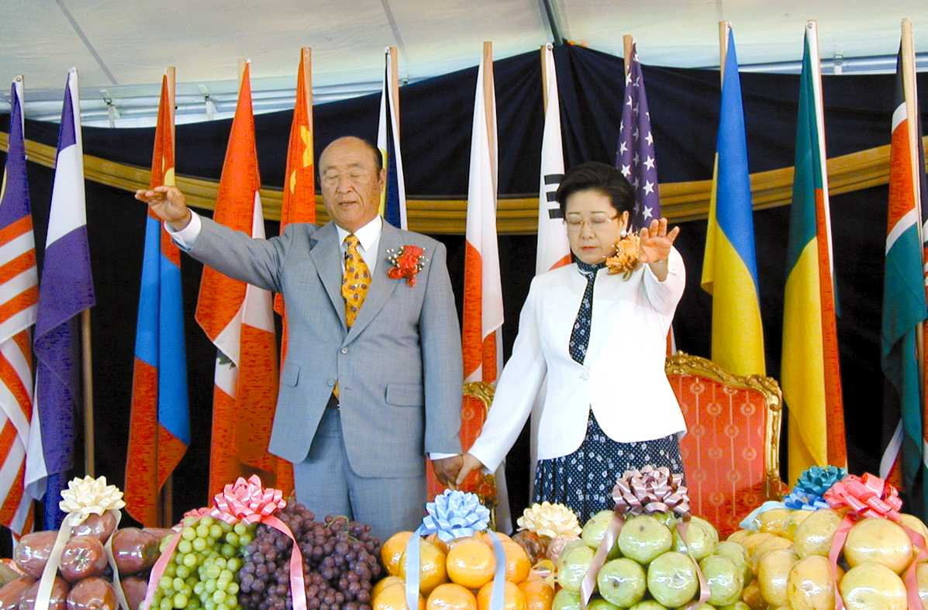
BLESS-ED
Blessing Life Guidance derived from
True Parents Words

Creating a Blessing Culture
We are looking for volunteers to join our team of researchers who are carrying out a systematic review of True Parents’ speeches in order to extract a representative sample of True Parents’ Words on the values, conventions, and practices of Blessed Central Families. Our ultimate goal is to create a Blessed Central Family Life Guidance manual.

Since the “Blessing” is a vertically revealed and initiated sacrament of rebirth and proper growth to the ideal, and ‘culture,’ which according to Merriam-Webster, is a “set of values, conventions, or social practices” as well as “the characteristic features of everyday existence,” we believe that initial efforts to create a Blessing culture should tap into the ultimate vertical source, i.e., Heavenly Parent and True Parents.

Contact Alice Fleisher for details at
Bcfcurriculum2017@gmail.com

The Blessed Central Family Life Guidance Curriculum Project is a grassroots initiative started in 2017 by Alice Fleisher and a small team of like-minded Unificationists. Our target for completing Phase I (collecting quotes phase) is 2022, with the manual being completed by 2025

